Building a continuous velocity model from acoustic data and drilling measurements

Construction d’un modèle continu de vitesse à partir de données acoustiques et de paramètres de forage
Jean Luc Mari^{1,2, *}, Kevin Gestin², and Pierre Gaudiani³

¹ Sorbonne Université, Paris, France
² SpotLight, Massy, France
³ Association Pédagogique et Expérimentale du Cher, Vesdun, France

Abstract. On an experimental site, situated in the Cher region (France), two boreholes have been drilled for field experiments. During the drilling, some parameters such as rate of penetration (ROP) and Torque have been continuously recorded. Full Waveform Acoustic logging (FWAL) and seismic experiments, such as refracted tomography, were conducted. A linear relationship between Torque-to-ROP ratio and acoustic velocity has been computed, in a root mean square sense, to obtain an estimated P-wave velocity log from drilling parameters. A specific procedure based on zoning process applied on acoustic data is used to force the torque to respect the trends of variation of the P-wave velocity. After calibration with acoustic velocity in the 30 – 192 m depth interval, and validation with tomographic velocity in the 0 – 12 m depth interval, drilling parameters allow a prediction of P-wave velocity from the surface up to the terminal depth of the borehole, with a 10% relative uncertainty. The acoustic velocity log from FWAL is by that way extended over the total heigh of the borehole.
Résumé. Sur un site expérimental, situé dans le Cher (France), deux puits ont été forés. Pendant le forage, certains paramètres tels que le taux de pénétration et le couple ont été mesurés en continu. Des diagraphies acoustiques en champ total ont été enregistrées dans les deux forages dans le but d’obtenir des logs de vitesse acoustiques. Des expérimentations de surface telles que de la tomographie de réfraction ont permis d’obtenir un modèle de vitesse des terrains traversés jusqu’à une profondeur de 12 m. Une relation linéaire entre la vitesse acoustique et le rapport couple sur taux de pénétration a été établie dans le but d’obtenir un modèle de vitesse continu des formations traversées à partir des paramètres de forage. La procédure mise en œuvre nécessite de contraindre le couple à suivre les ______________________________
*Corresponding author: jeanluc90.mari@gmail.com

variations à grande longueur d’onde du log de vitesse acoustique. Apres calibration sur les vitesses acoustiques dans l’intervalle 30-192 m et validation sur les vitesses sismiques dans l’intervalle 0-12 m, les paramètres de forage permettent de prédire la vitesse de compression des formations de la surface au fond de puits avec une incertitude relative de 10%. Réciproquement, le log de vitesse acoustique peut être étendu de la surface au fond de puits soit 200 m.

1 Introduction
An experimental site (Figure 1a), situated in the Cher region (central part of France), is located at the transition from the Triassic to the Jurassic.

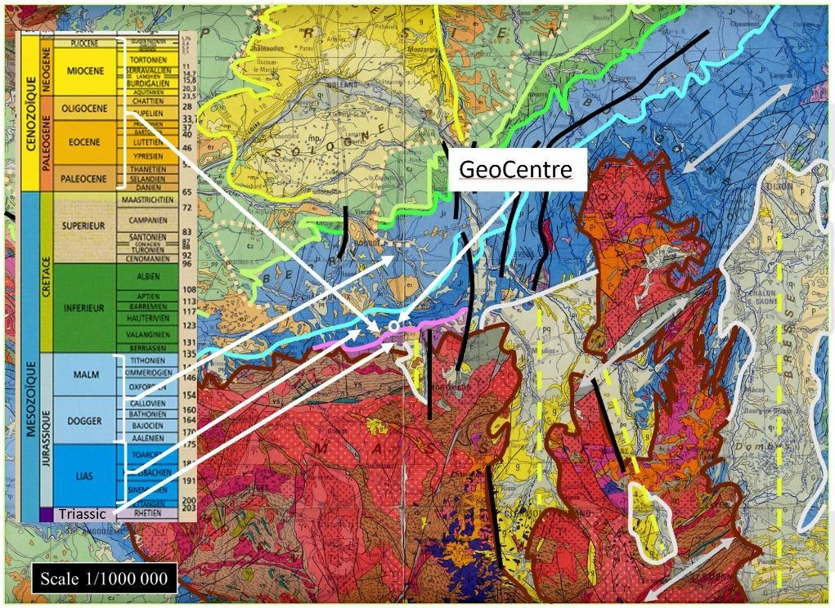(a)
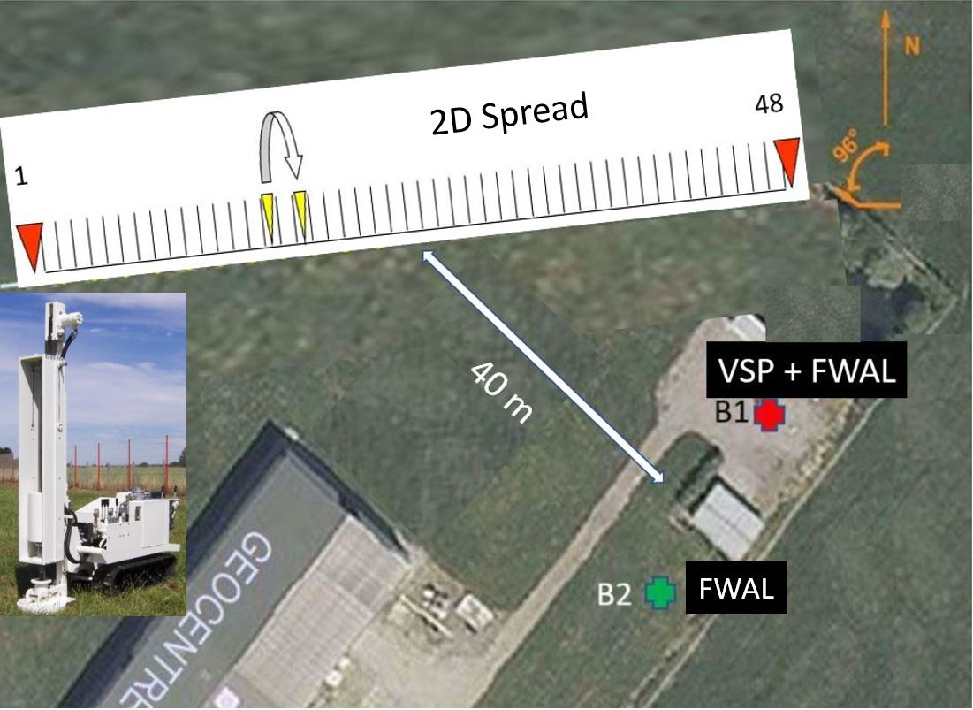(b)

Fig. 1. The experimental site. (a) location of the site and geological map. (b) 2D seismic spread, borehole locations (B1 and B2) and view of the seismic source. After [1].

Recent superficial deposits overlay a sedimentary formation with a thickness of about 200 m. The sedimentary formation is mainly composed of limestones up to 120 m and sandstones with some argillite and dolomite intercalations between 120 m and 200 m. The site belongs to Geocentre, a company involved in geotechnical studies and drilling. The site has been developed both for the training of students and for professionals, it is also used for experimental studies in near surface geophysics. The training in geophysics concerns the acquisition and processing of surface seismic data in 2D or 3D [1]. On the site, two boreholes have been drilled (Figure 1b). One of them (borehole B1) is steel cased hole, the other (borehole B2) is steel cased in the upper part, slotted PVC cased in the lower part. During the drilling, some parameters such as rate of penetration and Torque have been continuously recorded. Boreholes allow the acquisition of well seismic data such as vertical seismic profiles (VSP) and logging data such as full wave form acoustic data [1].
After a review of acoustic data recorded on the site, the paper shows how drilling parameters, acoustic logging, and refraction tomography can be merged for obtaining a very high-resolution continuous velocity model from the surface up to the terminal depth of the borehole.

2 Full wave form acoustic logging and refraction tomography

As indicated earlier, two boreholes are available at the site. They are marked by green and red crosses in figure 1b. Borehole B1 was drilled by Geocentre in 2006 but is now fully steel cased and cemented. Borehole B2 was drilled by Geocentre-Forsol in two phases between September 2019 and September 2020. During the drilling phases, some parameters such as the rate of penetration (ROP) and torque were continuously recorded. The first drilling phase from the surface up to 78 m depth resulted in a steel cased but not cemented borehole. Re-handling the borehole within the second drilling phase allowed to reach the depth of 200 m with a borehole completely cored between 78 and 200 m, then equipped with a slotted PVC casing.
In borehole B1, a vertical seismic profile (VSP) and Full waveform acoustic data were recorded. In borehole B2, only Full waveform acoustic data were recorded. On the site, a 2D seismic profile was recorded. Figure 1b indicates the location of the 2D seismic line.
  - Full wave form acoustic logging
Full waveform acoustic logging was run in the 2 boreholes [1]. The acoustic tool is a monopole type flexible tool equipped with a magnetostrictive transmitter (17-22 kHz) and two receivers (offsets:3 -3.25m Composite acoustic sections are obtained by the merge of acoustic data recorded in borehole B1 (steel cased hole) in the 30 – 78 m depth interval and in borehole B2 (slotted PVC cased hole) in the 78 – 192 m depth interval. Figure 2 shows the 3-m offset acoustic section. Between 0.5 and 0.8 ms, we can see locally resonances which indicate a poor cementation of the borehole. A cemented bound log (CBL) highlights the zones of poor cementation. We can see the refracted P-wave between 0.8 and 2ms, and the Stoneley after 2 ms. The picked times of refracted P-waves allow the computation of the P-wave velocity log (VP) in the 30- 192 m depth interval. The associated correlation coefficient log is used to evaluate the quality of the measurement [1]. At 120 m depth, we observe a strong delay of the wave trains, associated with a strong decrease of the acoustic P-wave velocity.

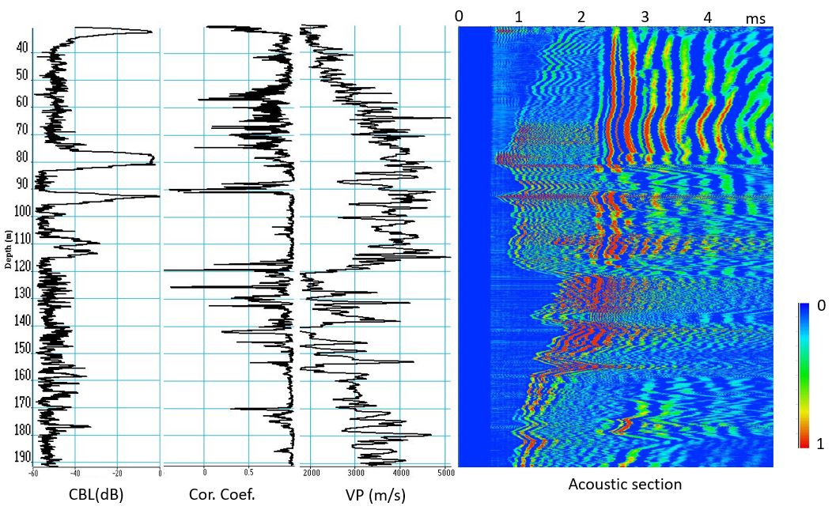

Fig. 2. Acoustic logs and full wave form acoustic section. After [1].

Between 120 and 192 m, the acoustic section can be subdivided in 3 acoustic units. The depth intervals associated with the acoustic units are: 120 – 140 m, 140 -152 m, 152 -192 m. In each unit, the acoustic velocity trend increases linearly with depth. We can also observe that the Stoneley waves are locally strongly attenuated.
  - Refraction tomography
For the 2D seismic acquisition (figure 1b), the receiver spread is fixed. It is composed of 48 geophones, 2 m apart. The source is a lightweight dropper (figure 1b) which is moved and fired between 2 adjacent geophones.
The first arrivals of all the shots recorded along the 2D profile have been picked for building a near surface velocity model by refraction tomography. The results of the tomographic inversion are shown in figure 3. The refraction tomography gives a P-wave velocity model in the first 12 m of the near surface.

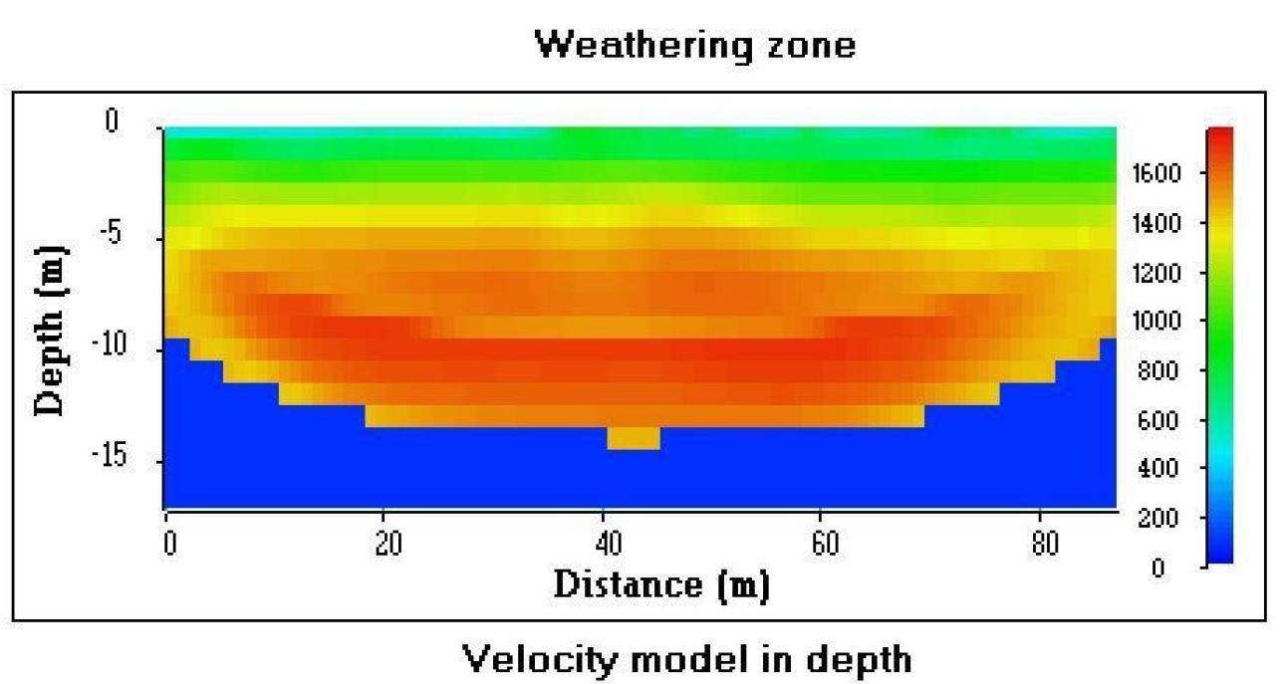
Fig. 3. Velocity model obtained by refraction tomography. After [1].

Consequently, there is a gap in the velocity model in the 12 – 30 m depth interval. In the next step we show how the drilling parameters, mainly drilling torque and rate of penetration (ROP), can be used to fill the gap of velocity and by that way extend continuously the acoustic velocity up to the surface and in the 192-200 m depth interval.

3 Drilling parameters
Mechanical specific energy, MSE, is a commonly used measure of drilling performance [2]. MSE is defined as the work required to pulverize a unit of volume of rock with the drill bit.
MSE is related to the drilling parameters: Torque (T), rotary speed (RPM), weight on bit (WOB), and rate of penetration (ROP). All the parameters are typically recorded during drilling operations. MSE, which has the units of pressure (Pa), can be computed using the following formula:

$MSE=\frac{T×RPM}{A×ROP}+\frac{WOB}{A}$ (1)

Where T, RPM, ROP and WOB must be expressed respectively in N.m, rad/s, m/s, N and A, the bit surface, in m².
MSE can be estimated by the torque term (T×RPM)/(A×ROP) which usually dominates the WOB term (WOB/A). MSE has been often correlated with logging data such as resistivity measurements or velocity measurements given by acoustic logging. Drilling parameters have also been correlated with geology as suggested by [3]:
- Pressure on the tool: it is the hydraulic load that is applied on the drilling tool. This parameter can be used to enhance layer of soft soil in which pressure on the tool is closed to zero.
- ROP: it represents the rate of penetration or vertical speed of the tool while drilling. This parameter gives information about the compacity of the soil, soft soils having high advance speed.
- Rotating torque: it represents the pressure (expressed in bar) that is applied to generate the rotation. It gives information about the nature of soil. For example, torque is higher in clayey soils than in sandy soils.
- Injection pressure: it is the pressure of the drilling fluid in the borehole. It increases when permeability of the soil decreases.

In this part, we recall the procedure used to obtain from MSE a continuous velocity log from the surface up to the terminal depth of the borehole [4,5]. During drilling, Torque (expressed in bar) and ROP (expressed in cm per hour c/h) have been recorded. Rotary speed (RPM) has not been recorded. Consequently, MSE is proportional to Torque-to-ROP ratio if RPM and bit surface A are assumed to be constant. In this part, we describe the procedure used to obtain from Torque-to-ROP ratio a continuous velocity log from the surface up to the terminal depth of the borehole. The formation velocity obtained from Torque-to-ROP ratio is referred as to VP-MSE and expressed as follows:

$VP-MSE=a\frac{T}{ROP}+b$ (2)

The coefficients a and b are computed to obtain an optimum fit (in the sense of a root mean square error E²) between acoustic velocities and MSE velocities (VP-MSE). Figure 4 shows the different steps to convert drilling parameters in P-wave velocity.
The P-wave velocity log is the superposition of a short wavelength component and a long wavelength component which gives the trends of variation of the P-wave velocity. A zoning or blocking method is used to evaluate the long wavelength component. One of the first zoning methods, proposed by [6], suggests studying the derivative of the dataset according to depth. When the derivative admits a high amplitude, one can expect a change in lithology or mechanical properties, such as velocity. One of the limitations of this type of blocking is that a change in lithology observed in the borehole may be associated with small variations of the studied parameter (velocity). Thus, the analysis of the derivative can allow potential areas of relatively similar, but however different, lithology to pass through. These methods allow mechanical parameters to be zoned into several units, within which the parameters are considered constant [7]. However, some parameters may vary within the same unit depending on the depth. This is the case with the acoustic velocity which increases linearly with depth, as it can be seen in different depth intervals: 30 – 80 m, 120 – 140 m, 140 -152 m, 152 -192 m (Figure 2). Zoning by constant value is not suitable. It is proposed to use a linear regression zoning method. The main idea is to explain the variance of the data by a linear regression relationship. The results of zoning or blocking process, applied on the acoustic velocity log, are shown in Figure 5 (top). The blocked velocity log, referred as” VP after blocking” displayed in red, highlights 7 acoustic units: 30 – 86.4 m, 86.4 – 95 m, 95 – 115.2 m, 115. 2 – 120.5 m, 120.5 – 138.7 m, 138.7 – 153.8 m, 153.8 -192 m. The correlation between the velocity logs before and after the zoning process is high (> 0.85).

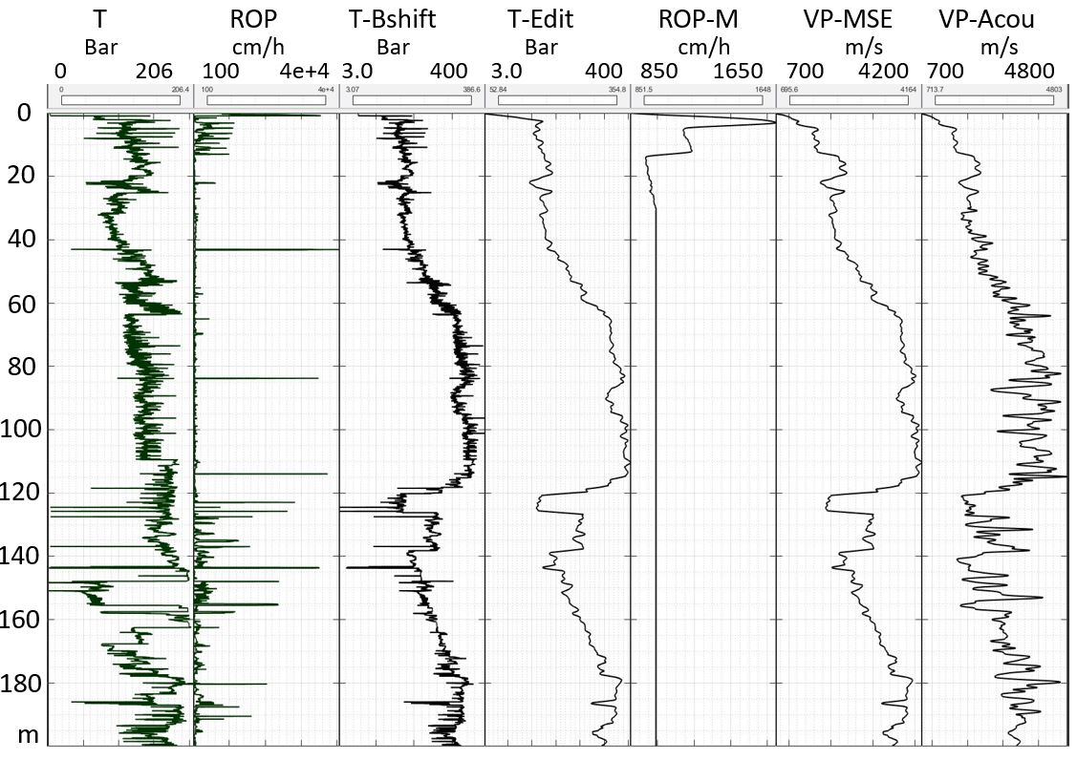
Fig. 4. Drilling parameters and acoustic logging. After [4,5]. From left to right: torque (T), rate of penetration (ROP), torque after block shift (T-Bshift) and editing (T-Edit), model of ROP (ROP-M), P-wave velocity from MSE (VP-MSE), P-wave velocity from acoustic logging (VP-Acou).

The raw drilling logs, Torque (T) and ROP, are corrupted by spikes. In the 30 – 192 m depth interval where the acoustic tool was run, the ROP is weakly corrupted by spikes, except in the 120 – 160 m depth interval where the density of spikes is much more important, but the amplitudes of the spikes remain weak. Consequently, in the 30 – 192 m depth interval, the ROP has been replaced by a constant value (average value: 990 cm/h). To recover acoustic velocity from Torque-to-ROP ratio, the torque log (T, figure 4) must be modified to respect the trends of variation of the P-wave velocity. Based on both visual inspection and results obtained by zoning, the torque log T is subdivided in depth intervals. The intervals are mainly associated with drilling stops and resumptions. In each interval, torque values are modified by adding a constant value ΔP which shifts the log in amplitude (pressure P).

Under the assumption that the Torque-to-ROP ratio is proportional to the formation velocity (eq.2), the set of corrections ΔP is adjusted to obtain:
- a corrected Torque which has a high correlation with the blocked acoustic velocity log
- a velocity model, referred to as VP-MSE, which fits (in the sense of a root mean square error E²) the acoustic velocity log, referred to as VP-Acou, under the assumption that there is a linear relationship between VP-Acou and VP-MSE.
The method of correction is equivalent to the Block shift method applied to the sonic log [8]. The Torque after block shift correction (T-Bshift, figure 4), has been edited to eliminate the spikes and filtered to have a vertical resolution equivalent to that of the acoustic velocity log (T-Edit, figure 4). Figure 5 (bottom) shows the torque log after block shift correction, editing and filtering, in the 30 – 192 m depth interval. The correlation coefficient with the blocked acoustic velocity log is high (> 0.9). Figure 6 shows a comparison between acoustic velocity (black curve) and predicted P-wave velocity from drilling parameters (VP-MSE, red curve).

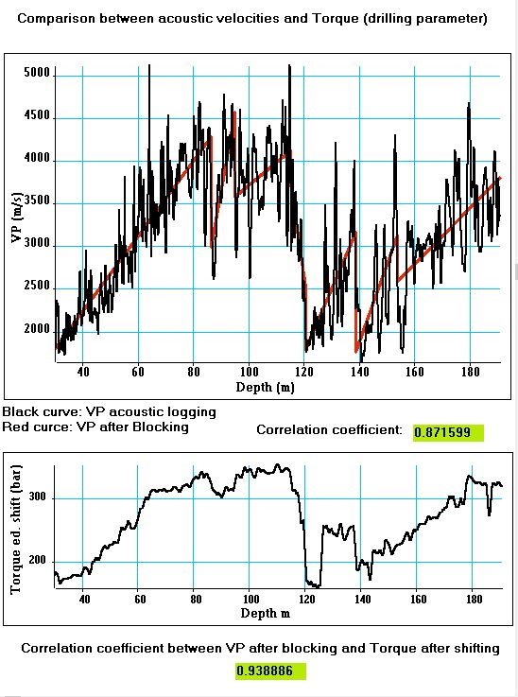
Fig. 5. Comparison between acoustic velocities and Torque (drilling parameter). After [5].

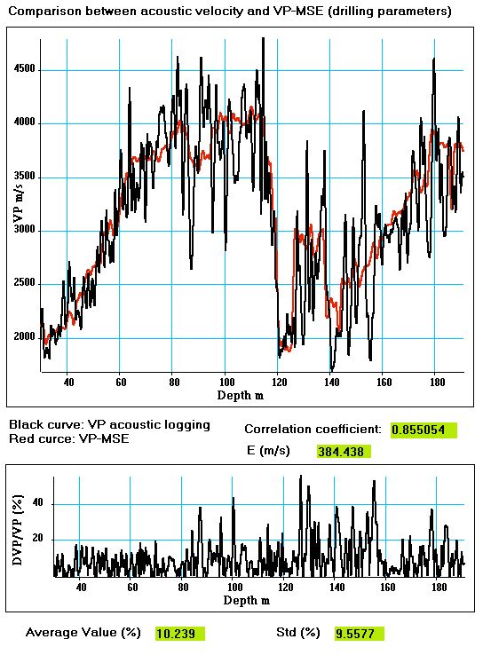(b)
Fig. 6. Comparison between formation velocities computed from drilling parameters (VP-MSE) with formation velocities obtained by acoustic logging. After [5].

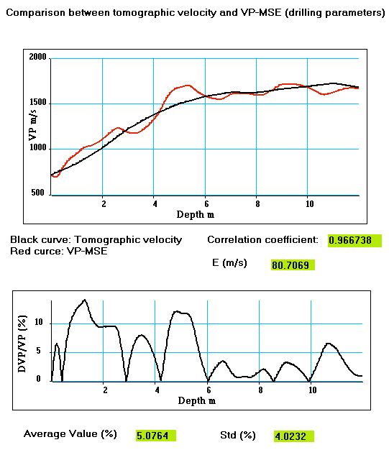

Fig. 7. Comparison between formation velocities computed from drilling parameters (VP-MSE) with formation velocities obtained by refraction tomography. After [5].

The correlation coefficient between the 2 logs is high and the error E is low. VP-MSE only gives the P-wave velocity trend associated with the geological formation, the relative uncertainties ΔV/V computed with acoustic velocity (VP-Acou) are of the order of 10 % in average (figure 9, bottom right).
In the first 15 m, the ROP, highly corrupted by noise (figure 4, ROP), cannot be combined with the edited torque (figure 4, T-Edit) to compute a velocity distribution. An estimate of the formation velocity is given by refraction tomography (figure 3). Consequently, a smooth ROP model has been recomputed using equation 2, edited torque values and velocity from refraction tomography in the 0-12 m depth interval. In the 12 – 30 m depth interval, the ROP model has been interpolated as seen in figure 4 (ROP-M curve). Figure 7 shows a comparison between tomographic velocity (black curve) and predicted P-wave velocity from drilling parameters (VP-MSE, red curve); the correlation coefficient between logs is high, the error E is weak, and the relative uncertainties are of the order of 5 % in average. After calibration with acoustic velocity in the 30 – 192 m depth interval, and validation with tomographic velocity in the 0 – 12 m depth interval, VP-MSE allows a prediction of P-wave velocity in the 12 – 30 m depth interval, with a 10% relative uncertainty.
Figure 4 shows the predicted P-wave velocity from MSE computed from the surface up to the terminal depth of the borehole (VP-MSE curve) and the extended acoustic velocity (VP-Acou curve).

4 Conclusion
Full Waveform Acoustic logging (FWAL) experiments is relatively simple and cheap, but the scale investigated does not exceed the close vicinity of the probed borehole. FWAL data are used both to evaluate the quality of borehole cementation and to obtain very high-resolution velocity log. During drilling operation, if drilling parameters such as Torque and rate of penetration (ROP) are recorded, they can be used to measure drilling performance by computing Mechanical Specific Energy (MSE).
A linear relationship between Torque-to-ROP ratio and acoustic velocity has been computed, in a root mean square sense, to obtain an estimated P-wave velocity from drilling parameters. A specific procedure based on zoning process applied on acoustic data is used to force the torque to respect the trends of variation of the P-wave velocity. After calibration with acoustic velocity in the 30 – 192 m depth interval, and validation with tomographic velocity in the 0 – 12 m depth interval, drilling parameters allow a prediction of P-wave velocity from the surface up to the terminal depth of the borehole, with a 10% relative uncertainty.
The extended acoustic velocity log has already been successfully used to calibrate and transform seismic sections in amplitude into seismic sections in pseudo-velocity and then in pseudo-porosity [1].

References
- J. L. Mari, F. Delay, G. Porel, P. Gaudiani, Characterizing flow in the first hundred-meter depth of a fractured aquifer using hybrid seismic methods, acoustic logging, and flow log measurements, Oil & Gas Science and Technology – Rev. IFP Energies Nouvelles 76, 62, https://doi.org/10.2516/ogst/2021048 (2021)
- R. Majidi, M. Albertin, N. Last, Method for pore pressure estimation using Mechanical Specific, Energy, IADC/SPE-178842-MS, IADC/SPE Drilling Conference and Exhibition, https://doi.org/10.2118/178842-MS (2016)
- M. Reboul, V. Subaskaran, Development and application in geotechnical engineering of a universal single composed parameter obtained from drilling parameters, proceedings of the XVII ECSMGE European conference, ISBN 978-0-7277-6067-8 (2019)
- J. L. Mari, K. Gestin, P. Gaudiani, Drilling torque – Acoustic logging: an effective do for calibrating near- surface seismic data, paper number: 2409, 82nd EAGE annual conference & exhibition, Amsterdam, The Netherland (2021)
- J. L. Mari, K. Gestin, P. Gaudiani, Characterizing a near-surface aquifer using hybrid seismic methods, acoustic logging, and drilling-parameter measurements, in: Parallel Geoscience, Technical paper, www.parallelgeo.com (2021)
- W.W. Sounder, G.R. Pickett, A Computerized Method for the Zonation of Digitized Well Logs. Paper SPE 4019 presented at the Fall Meeting of the Society of Petroleum Engineers of AIME, San Antonio, Texas, USA, 8–11 October, http://dx.doi.org/10.2118/4019-MS (1972)
- N. Adani, Data blocking or zoning: well-log-data application, Journal of Canadian Petroleum Technology, DOI:10.2118/154017-PA (2013)
- S. Boyer, J.L. Mari, Seismic surveying and well logging, Editions Technip, ISBN 2-7108-0712-2 (1997)

